PlayGroundX Issues

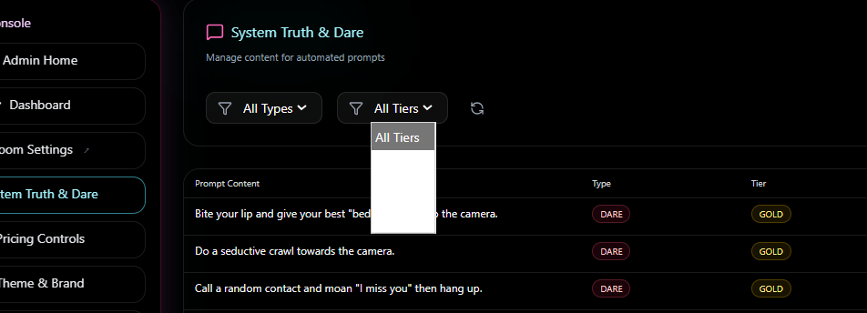
- It has to have the filters for all tiers, and all types. They do not show!

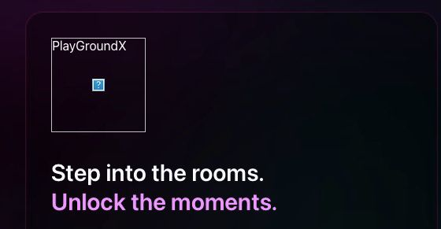
- This is on Apple Laptop, the site logo does not show! On Windows it does. If new user they cant have this issue.

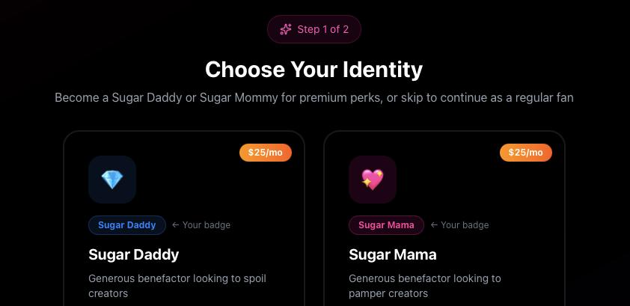
- These logos do not reflect from what I uploaded in admin settings with the new logos! Have them sync from Admin.
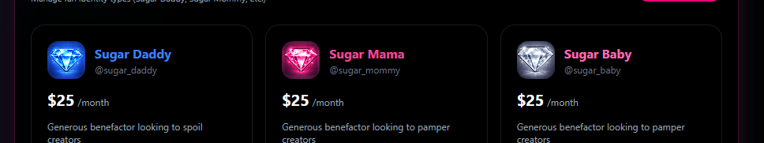
These I have in Admin.

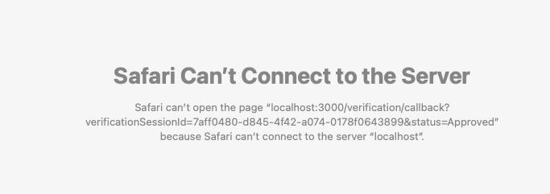
- After doing ID Verfiy, and I do it on the phone it says Id Verified then it went to this page! Need Fixing!
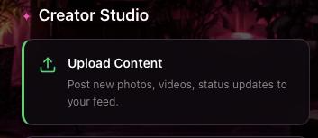
- This Upload Content does not work, it reloads instead of going to the content page. Also after fixing this, move Upload Content to Subscription Settings section with the weekly and monthly price settings besides it.

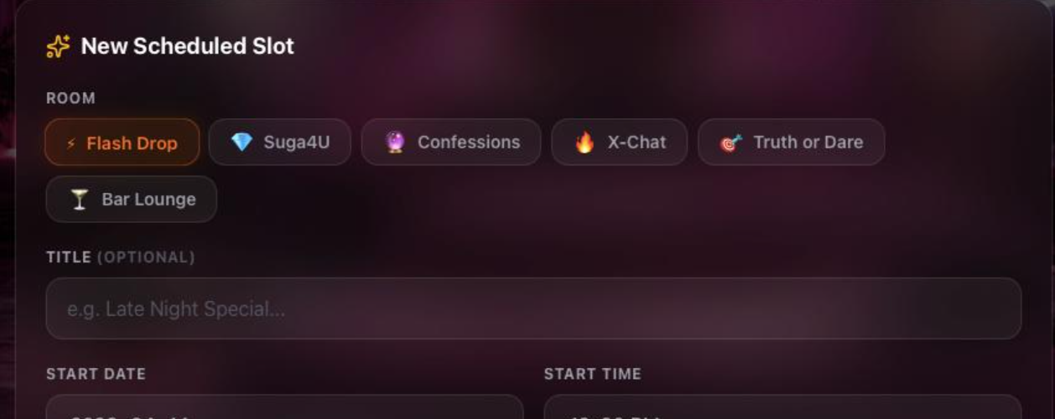
- Competitions is missing as an option

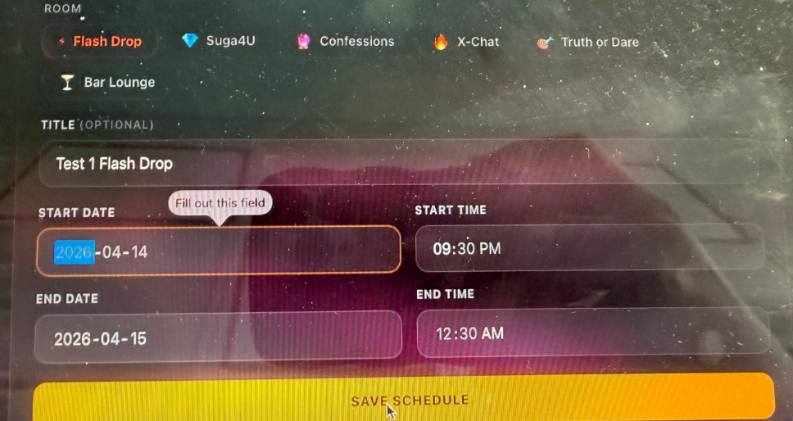
- Start Date field has an issue when try to save it will not and keep saying this
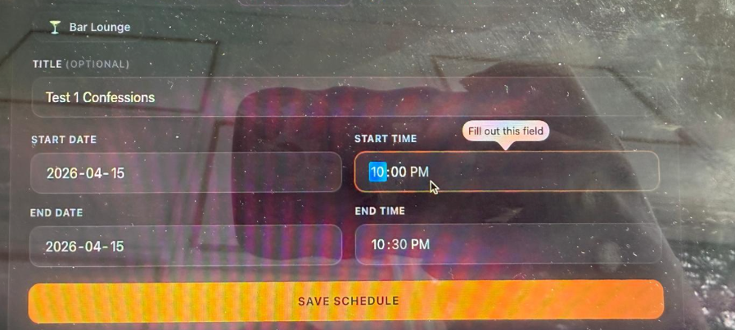
Same with start time. The fields are all a issue when setting.
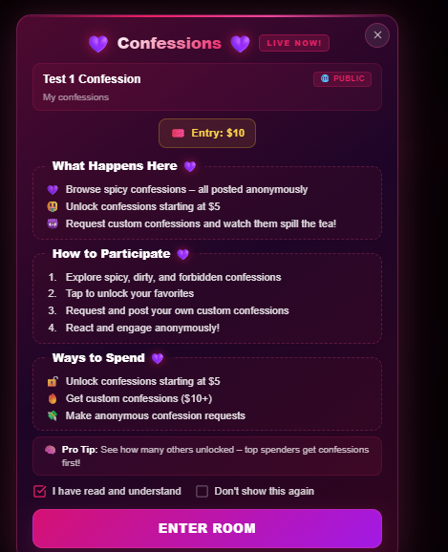
- Per Min Billing has to show with the global setting amount shown here like $2

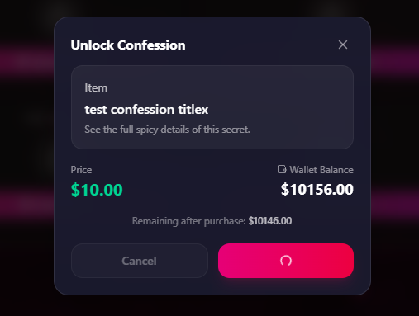
- It did not load from wallet there was error, then when I tried again it just keeps loading the button and wont load.

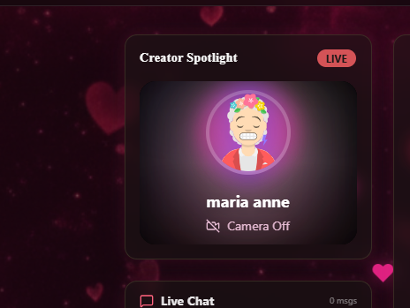
- Confessions room, video is too small. It needs to be larger I will show you the plan on zoom how to do this.

